ARPEGGIO

USER MANUAL

Overview

Fight enemies, acquire weapons and armor to augment your combat capabilities, and gain “experience points,” which reflect the veterancy of your player’s character. With enough experience points, your character can level up, increasing their “stats.” Stats are variables that represent natural combat prowess, such as agility, toughness, or muscular strength. Your character will also gain money (sometimes referred to as “gold”) to purchase armor or weapons. Additionally, your player’s character has a set amount of “Health Points” or “Hit Points” (henceforth referred to as HP). When your character’s HP is reduced to zero, your character has been killed. Whenever you move to the next stage or whenever you level up, your HP is restored to the maximum possible amount.

Tutorial

In the beginning, the user has to input a name and choose one of three classes. The Knight is a very tough, survivable character. The Rogue is evasive and lethal. The Berserker features a good HP pool and hits the hardest of them all. After playing through the delightful backstory in the java console, a window will appear, and you will be brought to the overworld screen.

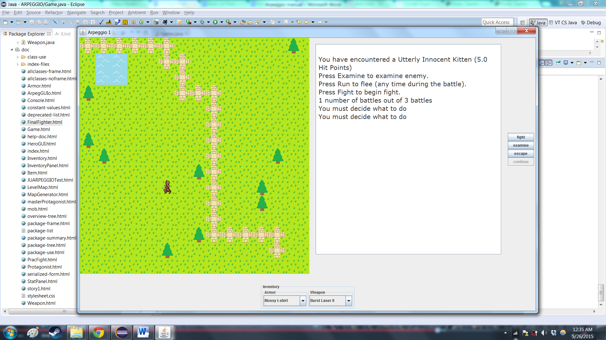

Movement

Arpeggio features a top-down overworld map screen where the user’s avatar can maneuver through the whole board using the up, down, right, and left arrow keys.

Fighting

When an encounter occurs, the “fight,” “examine,” and “run,” buttons will become clickable. The user will have to make a tactical evaluation of the situation; whether to run or to continue fighting and potentially gain loot and experience.

Inventory

The user can press the drop down menus on the inventory to switch the currently equipped gear on the character.